**Phase 1 project:**

**Project Title : SMART WATER FOUNDATION**

**Project ID :** proj_223731_Team_5

**College Code :** 6208

Name : R.Mohanraj

**College :** Gnanamani College of Technology

**Branch :** B.Tech/Information Techology

**Year :** IIIrd year

**Problem Definition:**

**ABSTRACT:**

The Smart Water Foundation project leverages the power of the Internet of Things (IoT) and the versatility of the 8051 microcontroller to revolutionize water management systems. With a growing global water crisis, efficient water resource management is imperative. This project integrates sensor networks, data analytics, and automation through the 8051 microcontroller to create a comprehensive solution.

The IoT aspect of the project involves deploying a network of water quality and quantity sensors in critical locations such as reservoirs, rivers, and distribution systems. These sensors continuously collect real-time data on water parameters, including pH levels, temperature, turbidity, and flow rates. The data is transmitted wirelessly to a central server for analysis.

The 8051 microcontroller serves as the brain of the system, responsible for processing the incoming data, making intelligent decisions, and triggering automated actions. Machine learning algorithms are employed to predict water quality trends and detect anomalies, ensuring early identification of contamination events or leaks. Additionally, the 8051 microcontroller controls valves, pumps, and actuators to optimize water distribution, reducing wastage and energy consumption.

This project aims to enhance water resource management by providing water authorities with valuable insights and control mechanisms. The integration of IoT and the 8051 microcontroller facilitates real-time monitoring, predictive maintenance, and remote management of water infrastructure, contributing to sustainability, conservation, and the efficient allocation of this precious resource. The Smart Water Foundation project sets the stage for a smarter, more resilient, and environmentally conscious water management system.

**Design Thinking:**

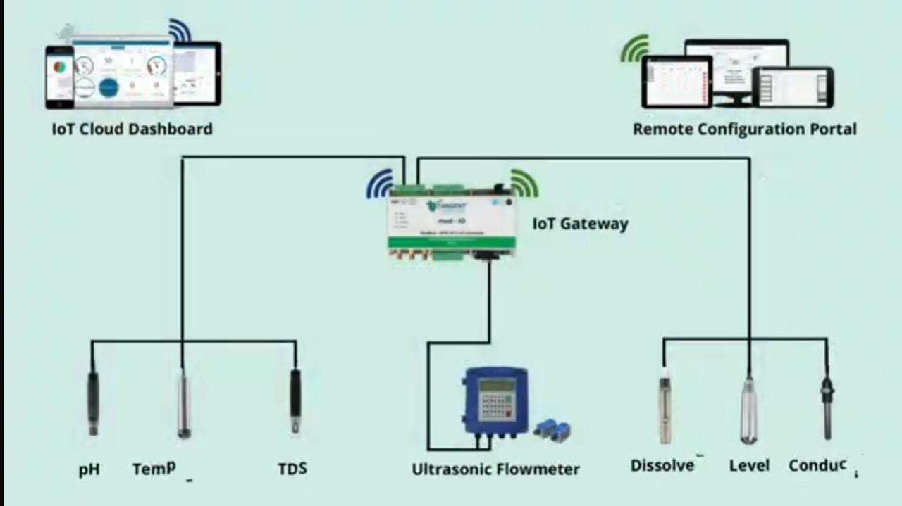

**REQUIREMENTS:**

* 8051 Microcontroller
* IoT Module
* ESP32
* Sensors
* Ultrasonic Sensors
* pH Sensors
* Turbidity Sensors
* Flow Sensors
* Actuators
* Power supply
* Communication
* MQTT
* HTTP
* IoT platform
* AWS IoT
* Azure IoT
* Google Cloud IoT
* User Interface
* Data storage